Parents Plus Programme

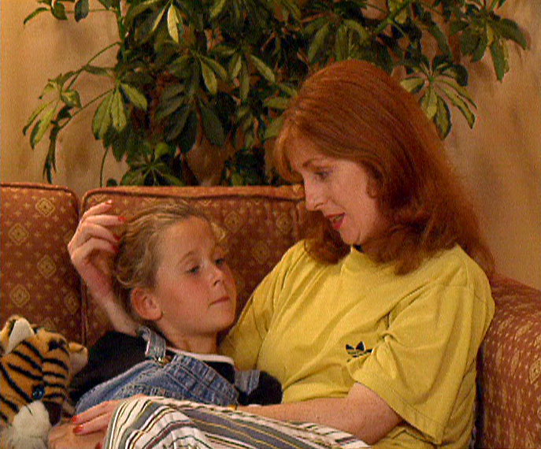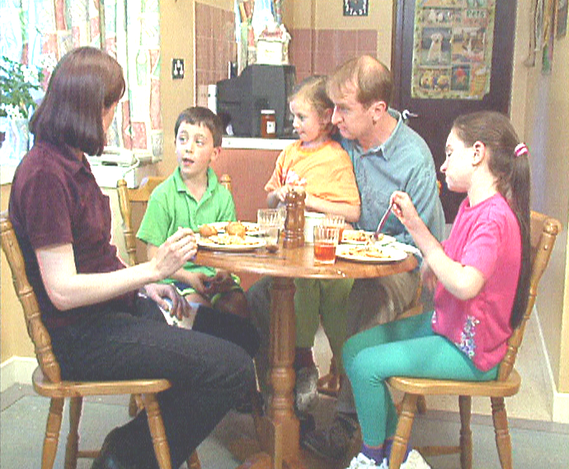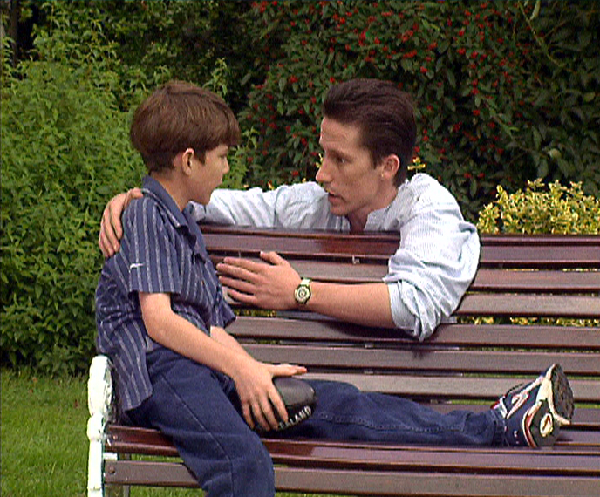

This FREE Parents Plus Community Course is a practical and positive course for parents of children aged 6 to 11 years who want to learn proven ways to: -
- Help your child learn and reach their full potential.
- Develop a close and warm relationship with your children and to enjoy being their parent.
- Set rules and establish positive routines in the home.
- Manage difficult behaviour and discipline problems.
- Solve childhood problems in a positive way that helps your child learn.

The course does not propose to find magic answers but hopes to help parents to gain the support of other parents and to find down-to-earth solutions for difficult situations. The focus of the course is positive and aims to build on your strengths as a parent and what you are already doing right. The course is FREE and is open to ALL parents who live in Dublin 15. If you are parenting alone, please feel free to bring along another supportive person. Booking early is advisable as places are limited.
Practical Details
This eight-week course is facilitated by the HSE Primary Care Team Social Work and Speech & Language Therapy Departments in Dublin 15.

The next course starts:

Date: Wednesday 11th March 2015 (for 8 weeks)

Time: 9.30am – 12.45pm

Venue: Hartstown Health Centre, Cherryfield Lawns, Hartstown, Dublin 15.

Facilitators: Olive Beattie (Social Worker) & Neasa Ní Liatháin (Speech & Language Therapist).

Information Morning: Wednesday 4th March 2015 at 10 a.m. in Hartstown Health Centre

Booking: To book your place on the course you can contact Olive Beattie on 01-8297210 or Neasa Ní Liatháin on 01-8662836.

**Places are limited so please book early**

This eight-week course is facilitated by HSE Dublin 15 Primary Care

