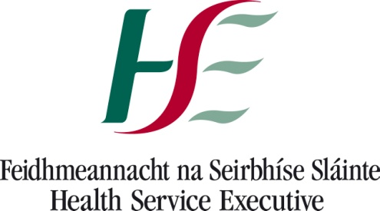
Health Service Executive
Dept of Public Health
Dr. Steevens Hospital,
Dublin 8
D08 W2A8
Tel: (01) 635 2145
Fax: (01) 6352103

Date: 21/02/2018

Dear Parent,

The Department of Public Health has been informed of a suspected case of meningococcal meningitis in a student who attends Powerstown Educate Together NS Tyrrelstown.

While it is very unlikely that there will be further cases in the school, it is important to be aware of the symptoms of this illness - these include headache, high temperature, vomiting, neck pain, dislike of bright lights, a red purple rash which does not fade on pressure and dizziness.

Some or all of the above symptoms may be present. Seek medical attention without delay if you are concerned.

The enclosed leaflet will give you further information about the disease.
Should you need any further information, please contact your general practitioner or a public health doctor at the above address / phone number.

Yours sincerely,

Dr Gamuledu Nthekela
MCRN 328744
_______________________
Senior Medical Officer

